Notice: Do submit project synopsis to respective lab teacher by 21/08/2026
Sem: V
Academic Year: 2026-27 Date: 10/8/2026

DBMS LAB MINI PROJECT SYNOPSIS
Title: Online Examination System

Abstract:

Designing the database which enables the Students & Teachers to register for the system. Students are allowed to take the online test and see their progress. Also, to enable the Teachers to add, delete, update the test Questions and also to keep track of the Students progress.

Description of Modules
Eg:
Registration Module:
Add/Delete/Update Module:
Result Module

System Requirement

Tools to be used
Front End tools
Back End tools
Other tools

ER Diagram:
Draw on A4 size paper neatly with pencil and ruler showing all the concepts covered in ER and EER

Schema Diagram:
Convert ER to relational table and draw schema diagram on separate A4 size paper

Team Details :
Sr.No | Roll No | Name of Students | Signature
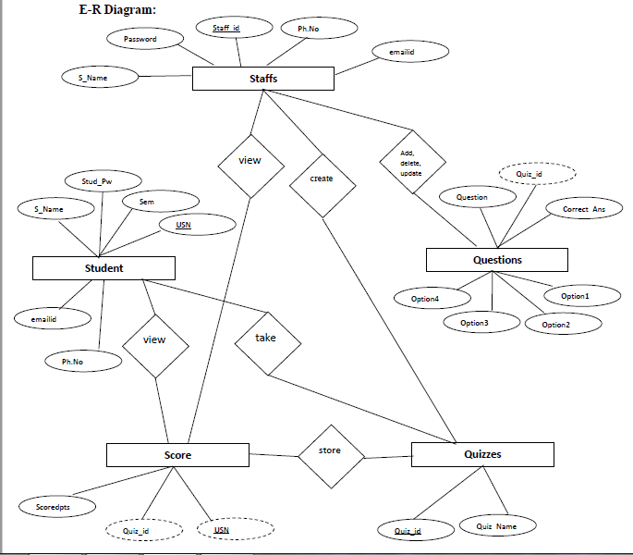

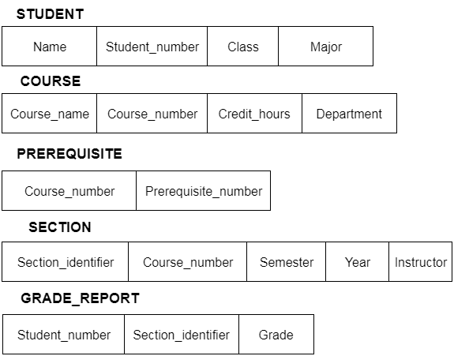
Schema Diagram

